Technical documentation
Table of Contents
1 Introduction 2
2 Configuration 2
3 Connected HW 3
4 Initialization 3
5 Bonding 3
6 Un-bonding 4
7 Other 4
8 Peripherals 4
8.1 Custom peripheral(s) 4
8.1.1 Read Temperature 4
9 FRC 5
9.1 Temperature - 0xC0 5
10 Memory 5
11 Autoexec and/or IO Setup 5
12 Operation 5
13 Example 5

Introduction
- HW Profile ID 0xXXXX
- HW Profile Version 0xVVVV

Short description of the device. This document specifies Custom HW Profile for PRODUCT. The device is used to measure the temperature and humidity. It also controls a power relay.

The profile is intended for:
- Transceiver DCTR-7x??
- DPA V4.00, IQRF OS 4.03
- STD or LP mode
- Coordinator or Node device

Optional note: Important: as the internal and/or external EEPROM contains some data do not forget to upload internal EEPROM.

Configuration
Specify the mandatory configuration settings. The following highlighted settings are mandatory. Others are optional or have to be set by the user.
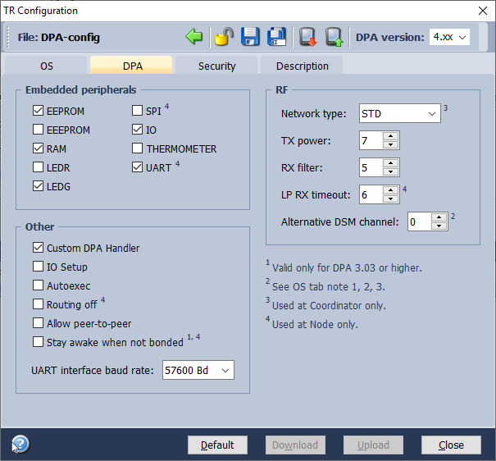

Connected HW
Describe the connected HW if necessary.

Example: DS18B20 temperature sensor is connected to MCU pin Q6 = PC3. The same pin must be connected by a pull-up resistor (value approx. 5k) to DS18B20 VDD pin. The DS18B20 VDD is connected to 3.3V, so the standard (but not parasite) power is used.

Initialization
Describe the behavior of the device when it starts.

Example: When device boots (even before optional bonding and un-bonding) it disables MCU internal pull-up resistors at Q12=PB4, Q10=PB7, and Q13=PE3. When the bonded device starts it configures the temperature sensor to the 11bit resolution. The following GPIOs are set as outputs and set to 0 value: RA0, RC2.

Bonding
Describe the bonding procedure.
A Node to be bonded must be in the unbonded state. It is indicated by red LED flashing (or specify your indication).

It is possible to bond a Node by several methods:
- Local Bonding
- The Node to be bonded must be in direct range with the Coordinator.
- Press the button XX (specify and describe it on the image) on the Node side.
- The Node to be bonded must have the Access Password (the same as it is used by the Coordinator) specified in TR Configuration.
Local bonding can be invoked by DPA command Bond node sent from Coordinator. After sending this command, the action (the button XX pressing) to invoke the bonding must be accomplished within 10 s.
For details, see the IQMESH Network Deployment document.
- Smart Connect
- The Node to be bonded doesn’t need to be in direct range with the Coordinator.
- No action (e.g. a button-press) is required on the Node side.
- The Node to be bonded doesn’t need to have the Access Password of the given network specified in TR Configuration.
Smart Connect can be invoked by the DPA command Smart Connect sent from Coordinator. The main input parameters of this command are IBK and MID of the Node to be bonded. They can be found on the device (MID, IBK, IQRF Smart Connect code, IQRF Smart Connect QR code) and can be read and sent by an application (e.g. by reading IQRF Smart Connect QR code from IQRF Network Manager or by sending MID and IBK parameters from IQRF IDE).
For details, see the IQMESH Network Deployment document.
- Autonetwork
- The Node to be bonded by Autonetwork doesn’t need to be in direct RF range with the Coordinator but must be in the range of other nodes are in the network or will be added during the running Autonetwork.
- No action (e.g. a button press) is needed on the Node side.
- All Nodes to be bonded must have specified the same Access Password as the Coordinator.
For details, see the IQMESH Network Deployment document.

Un-bonding
Describe the un-bonding procedure depending on your hardware.

Example: To un-bond the already bonded node the button must be kept pressed for minimum 2s after the device starts. During this time LED is on. When the LED goes off after 2s the button must be released within 0.5s to execute un-bonding. Then the formerly described bonding procedure continues. Such complicated un-bonding procedure is needed in order to prevent unwanted un-bonding caused by accidental button press after the device is reset.

Other
Another thing to note.

Example: Before device goes to RFPGM mode initiated by DPA command, the program sets pin Q8 = PC5 to 0.

Peripherals
List all peripherals. Describe in detail the commands for peripherals which are not standardized. Provide the link for the appropriate IQRF Standard manual for standardized peripherals
https://www.iqrfalliance.org/techDocs/).

Custom peripheral(s)

Read Temperature
Describe a command: PCMD = 0x00
Reads the temperature from a Dallas DS18B20 sensor.

Request
NADR | PNUM | PCMD | HWPID
NADR | 0x20 | 0x00 | 0xXXXX or 0xFFFF

Response
NADR | PNUM | PCMD | HWPID | ErrN | DpaValue | 0 … 1
NAdr | 0x20 | 0x80 | 0xXXXX | 0 | ? | Temperature
Temperature 16-bit temperature value read from DS18B20 chip. See DS18B20 datasheet.

If the DS18B20 is not detected or reading error occurs then ERROR_FAIL DPA error code is returned.

FRC
Describe the FRC commands which are not compliant with IQRF Standard. Provide the link for the appropriate IQRF Standard manual for standardized commands.
https://www.iqrfalliance.org/techDocs/).

Describe implemented FRC commands: All implemented FRC commands are FRC byte type. Generally the byte FRC must not return a zero byte because the zero value indicates that the device did not return a value as it did not communicate at all.

Temperature - 0xC0
Example: This FRC command returns temperature value in °C, integer part, not rounded from the Dallas sensor. If resulting temperature is 0°C, which would normally equal to value 0, then a fixed value 0x7F is returned instead. This value substitution makes it possible to distinguish between devices reporting 0°C and devices not reporting at all. The device would normally never return a temperature corresponding to the value 0x7F, because +127°C is out of working temperature range. In case of error reading the temperature from the sensor the returned value is 0x80 = -128 °C.

Memory
Optionally describe the content of the memories.

Example: Peripheral EEPROM byte at address 0 contains a timeout at minutes (default value is 5) after which the following GPIOs are set to 0 when there is no communication (no request, no FRC) with coordinator:
- RC5
- RB4
1st byte of the PeripheralRAM at address 0 contains the status value. The byte at address 1 contains the last read temperature value.

Autoexec and/or IO Setup
Optionally describe used Autoexec or IO Setup.

Example: The Autoexec opens and setups UART peripheral at 9 600 baud rate.

Operation
Describe a device logic, indicators, buttons etc.
Example: The coordinator device periodically polls all bonded nodes by reading their custom peripheral. The DPA response from the node is then transferred by the SPI interface to the master system. The delay between polling nodes is fixed to 5s.
The orange LED is on when the limit temperature was reached.

Example
An example usage of the implemented HWP: Following is data collected by IQRF Cloud from GSM-GW with inserted coordinator device. Record #155 is ...

155 | 2015-01-27 14:26:28 | 2015-01-27 14:25:56 | Rx | 20 | 00.00.FF.3F.12.04.00.00.13.02.00.FD.22.00.00.12.  04.01.00.01

